Molokini Analysis

# Written by Steve Scherrer - July/August 2021

## Background

This notebook documents preliminary analysis of tracking data for fish tagged in Molokini Crater between 2020-05-16 and 2021-05-24.

The purpose of this study is to understand how human impacts affect the fish of Molokini Crater

We are particularly interested in answering the following hypotheses: 1. Is the presence of fish affected by vessel presence

1. Does the proportion of time fish are present within the crater negatively correlated with vessel presence?

Proposed Approach: 1. Begin by calculating the number of each species tagged and basic summary statistics 2. Calculate Metrics - Receiver Use - Pianka’s Niche Overlap - residency 3. Make the following plots - Map - Receiver locations - Map - Average receiver use by Species - Scatterplot - day night plots - Bar Plot - The number of detections per day (individual) - Bar Plot - The number of individuals detected (species) - Line Chart - The proportion of individuals detected n days after tagging (30 day moving average by species) - Bar Plot - Daily vessel traffic - Scatter Plot - vessel traffic vs. proportion of fish detected in crater daily (scatterplot by species) 4. Perform the following statistical Tests - Compare Residency Rates by Species - Compare residency by species, size, and time at liberty - Create a GLM comparing # of individuals in crater regressed against boat traffic and species using AR(1) term on dependent variable on some time scale (daily? 6 hours? depends on resolution of vessel data)

# Workspace Setup

## Establish Directory Heirarchy

project_directory = '/Users/stephenscherrer/Documents/Programming/Projects/Molokini'  
scripts_directory = file.path(project_directory, 'Analysis Scripts')  
data_directory = file.path(project_directory, 'Data')  
results_directory = file.path(project_directory, 'Results')  
figure_directory = file.path(results_directory, 'Figures')

## Source package dependencies and utility functions from ‘Utility Functions.R’ file

## Load Data

* load various datafiles

## Files from VUE   
molo_df = load_vemco_data(file.path(data_directory, 'VUE_Export.csv'))  
false_detections_df = load_fdf_report(file.path(data_directory, 'FDA.csv'))  
  
## Vessel Traffic data  
vessel_df = load_vessel_data(file.path(data_directory, "Molokini_Master_June_21.csv"))  
  
## Metadata Files  
tagging_df = load_tagging_data(file.path(data_directory, 'Molokini_Fish_Tagging_master.xlsx'))  
  
# receiver_df = load_receiver_data(file.path(data_directory, ))

## Clean Data

* Associate detections with time of day (day, night, dawn, dusk)
* Remove detections from tags not associated with this study
* Remove false detections

## Associate detections with time of day  
molo_df = get_time_of_day(molo_df)  
  
## Combine vue df with tagging df - remove irrelevant tags in the process  
molo_df = inner_join(x = molo_df, y = tagging_df[ ,c('tag_id', 'species', 'fork_length', 'tagging_date' )], by = 'tag_id')  
  
## Filter false detections  
# molo_df = filter_false_detections(molo_df)  
  
## Reclass vessel_df date because R keeps implicitly recasting values...  
vessel_df$date = as.POSIXct(as.numeric(vessel_df$date), origin = '1970-01-01', tz = 'HST')  
  
## remove vessel data before start of study  
vessel_df = vessel_df[vessel_df$date >= min(molo_df$datetime), ]

# Exploratory Data Analysis

## Count of individuals tagged by species

## Get count of individuals tagged by species  
tags_by_species = aggregate(tag_id ~ species, data = tagging_df, FUN = uniqueN)  
 colnames(tags_by_species) = c('species', 'tagged')  
   
## Merge with count of individuals detected by species  
tags_by_species = left_join(tags_by_species, aggregate(tag_id ~ species, data = molo_df, FUN = uniqueN), by = 'species')  
  
## Replace NA values with 0  
tags_by_species[is.na(tags_by_species)] = 0  
  
print(tags_by_species)

## species tagged tag_id  
## 1 grey reef shark 2 2  
## 2 kahala 2 0  
## 3 omilu 4 4  
## 4 sandbar shark 1 1  
## 5 uku 1 0  
## 6 ulua 1 1  
## 7 whitetip reef shark 1 1

## Summary Statistics

# Time at liberty  
time_at_liberty = calculate_time_at_liberty(molo_df)  
  
# Days Detected  
days_detected = calculate_days_detected(molo_df)  
  
# % of days detected  
detection_stats = merge(x = days_detected, y = time_at_liberty[ ,c('tag_id', 'days_at_liberty')], on.x = 'tag_id', on.y = 'tag_id')  
detection_stats$percent_days_detected = round(detection_stats$unique_days / detection_stats$days_at_liberty, 4) * 100  
  
# Merge with tagging data to get fish info  
detection_stats = merge(x = tagging_df[ ,c('tagging_date', 'species', 'tag_id', 'fork_length')], y = detection_stats, on.x = 'tag_id', on.y = 'tag_id')  
detection_stats = detection_stats[order(detection_stats$species, detection_stats$tagging_date, detection_stats$tag_id), ]  
print(detection_stats)

## tag_id tagging_date species fork_length unique_days  
## 5 47513 2020-05-27 grey reef shark 93.0 360  
## 4 39194 2020-07-01 grey reef shark 101.0 60  
## 1 30711 2020-05-26 omilu 44.0 362  
## 2 30754 2020-05-27 omilu 38.0 362  
## 7 51591 2020-05-27 omilu 49.5 362  
## 6 51590 2020-05-28 omilu 37.0 360  
## 3 30755 2020-07-01 sandbar shark 112.0 25  
## 8 51593 2020-07-01 ulua 94.0 270  
## 9 51594 2020-07-23 whitetip reef shark 67.0 254  
## days_at_liberty percent_days_detected  
## 5 374 96.26  
## 4 78 76.92  
## 1 363 99.72  
## 2 363 99.72  
## 7 363 99.72  
## 6 361 99.72  
## 3 309 8.09  
## 8 327 82.57  
## 9 288 88.19

# Metric Calculations

## index of receiver use

## sum all spp, sum all individuals (detections of tag at given reciever / all detections of tag)  
  
## Calculate unique detections per tag per receiver station  
detections_per_tag_per_receiver = aggregate(datetime~tag_id+receiver+species, data = molo_df, FUN = uniqueN)  
colnames(detections_per_tag_per_receiver) = c('tag_id', 'receiver', 'species', 'detections')  
  
## Calculate receiver use metric for each fish and receiver pair  
detections_per_tag_per_receiver$receiver_use = 0  
for (species in detections_per_tag_per_receiver$species){  
 for (i in 1:nrow(detections_per_tag_per_receiver)){  
 detections_per_tag_per_receiver$receiver_use[i] = detections_per_tag_per_receiver$detections[i] / sum(detections_per_tag_per_receiver$detections[detections_per_tag_per_receiver$tag_id == detections_per_tag_per_receiver$tag_id[i]])  
 }  
}  
  
## Calculate average receiver use metric for each tag - Omit stations with no use as this would bias metric  
indvidual_receiver_use = aggregate(receiver_use~tag_id+species, data = detections_per_tag_per_receiver[detections_per_tag_per_receiver$receiver_use > 0, ], FUN = mean)  
  
## Add this information to detection_stats  
detection_stats = merge(detection_stats, indvidual_receiver_use, on = 'tag_id')  
  
## Calculate receiver use metric by species  
species_receiver_use = aggregate(receiver_use~species, data = indvidual_receiver_use, FUN = mean)  
colnames(species_receiver_use) = c('species', 'receiver_use')  
  
print(species_receiver_use)

## species receiver_use  
## 1 grey reef shark 0.1428571  
## 2 omilu 0.1428571  
## 3 sandbar shark 0.2500000  
## 4 ulua 0.1428571  
## 5 whitetip reef shark 0.1428571

## Calculate Pianka’s Niche Overlap Index - Pianka (1973) The Structure of Lizard Communities

0 = no overlap, 1 = perfect overlap

## Aggregate data averaged by species  
receiver_use_aggregated_by_species = aggregate(receiver_use ~ species + receiver , data = detections_per_tag_per_receiver, FUN = mean)  
 colnames(receiver_use_aggregated_by_species) = c('species', 'receiver', 'avg_use_index')  
   
## Reshape from Long to Wide format  
receiver_use_aggregated_by_species_wide = dcast(receiver_use_aggregated_by_species, species ~ receiver)

## Using avg_use_index as value column: use value.var to override.

## Get all species combinations   
species_combos = data.frame()  
for (i in 1:nrow(receiver_use_aggregated_by_species_wide)){  
 if(i != nrow(receiver_use_aggregated_by_species_wide)){  
 for (j in (i+1):nrow(receiver_use_aggregated_by_species_wide)){  
 species_combos = rbind(species_combos, data.frame('species_1' = receiver_use_aggregated_by_species_wide$species[i], 'species_2' = receiver_use_aggregated_by_species_wide$species[j]))  
 }  
 }  
}  
  
## Change any NA values to zero  
receiver_use_aggregated_by_species_wide[is.na(receiver_use_aggregated_by_species_wide)] = 0  
  
## Calculate Pianka's index for all pairs  
species_combos$pianka_index = 0  
for(i in 1:nrow(species_combos)){  
 species_combos$pianka_index[i] = sum(receiver_use_aggregated_by_species_wide[receiver_use_aggregated_by_species_wide$species == species_combos$species_1[i], -1] *   
 receiver_use_aggregated_by_species_wide[receiver_use_aggregated_by_species_wide$species == species_combos$species_2[i], -1]) /  
 (sqrt(sum(receiver_use_aggregated_by_species_wide[receiver_use_aggregated_by_species_wide$species == species_combos$species_1[i], -1] ^ 2) *   
 sum(receiver_use_aggregated_by_species_wide[receiver_use_aggregated_by_species_wide$species == species_combos$species_2[i], -1] ^ 2)))  
}  
  
## Round to 3 digits  
species_combos$pianka_index = round(species_combos$pianka_index, 3)  
  
print(species_combos)

## species_1 species_2 pianka_index  
## 1 grey reef shark omilu 0.578  
## 2 grey reef shark sandbar shark 0.873  
## 3 grey reef shark ulua 0.654  
## 4 grey reef shark whitetip reef shark 0.877  
## 5 omilu sandbar shark 0.154  
## 6 omilu ulua 0.274  
## 7 omilu whitetip reef shark 0.788  
## 8 sandbar shark ulua 0.760  
## 9 sandbar shark whitetip reef shark 0.674  
## 10 ulua whitetip reef shark 0.730

## Plots

Study Area

## Plot study area and receivers  
molo_basemap = get_map(location = c(lon = -156.496331, lat = 20.633007), zoom = 16, maptype = 'satellite')

## Source : https://maps.googleapis.com/maps/api/staticmap?center=20.633007,-156.496331&zoom=16&size=640x640&scale=2&maptype=satellite&language=en-EN&key=xxx-hggZe5I57UhGHb8

receiver_map = ggmap(molo_basemap) + geom_point(data = molo_df, mapping = aes(x = lon, y = lat), col = 'red') + labs(x = '°Longitude', y = '°Latitude', title = 'Receiver Locations') + ggsave(filename = 'Receiver Locations Google Map.pdf', path = figure_directory)

## Saving 5 x 4 in image

print(receiver_map)

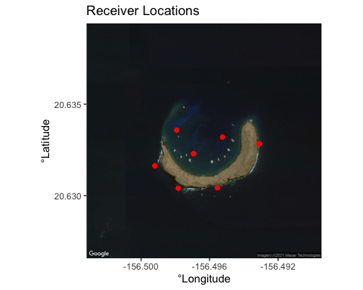

### Species Use Plots

## Get average use of receiver by species   
species_receiver_use = aggregate(receiver_use~species+receiver, data = detections_per_tag_per_receiver, FUN = mean)  
 colnames(species_receiver_use) = c('species', 'receiver' , 'receiver_use')  
   
## Merge with lat lon positions for each receiver from molo_df  
receiver_postions = unique(molo_df[ ,c('receiver', 'lat', 'lon')])  
species_receiver_use = merge(x = species_receiver_use, y = receiver_postions, on = 'receiver', all.x = T, all.y = F)  
  
## Make species plots for receiver use by species  
for(species in unique(species_receiver_use$species)){  
 receiver_use_by_spp = ggmap(molo_basemap) +   
 geom_point(data = species_receiver_use[species_receiver_use$species == species, ],   
 mapping = aes(x = lon, y = lat, color = 'red', size = receiver_use)) +   
 labs(x = '°Longitude', y = '°Latitude', title = paste('Receiver Use by ', species, sep = '')) +  
 ggsave(filename = paste('Receiver Use by ', species, '.pdf', sep = ''), path = figure_directory)  
 print(receiver_use_by_spp)  
}

## Saving 5 x 4 in image  
## Saving 5 x 4 in image

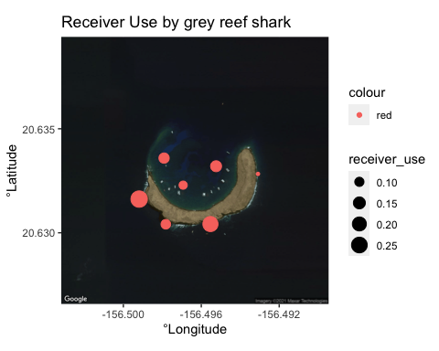

## Saving 5 x 4 in image

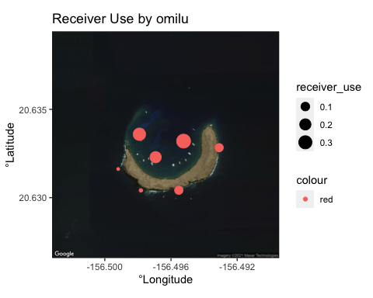

## Saving 5 x 4 in image

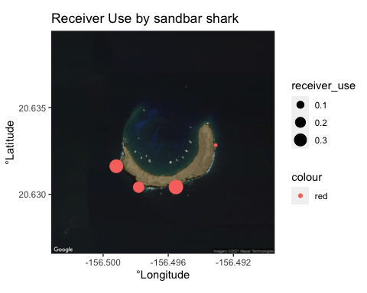

## Saving 5 x 4 in image

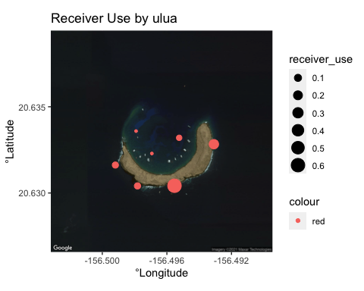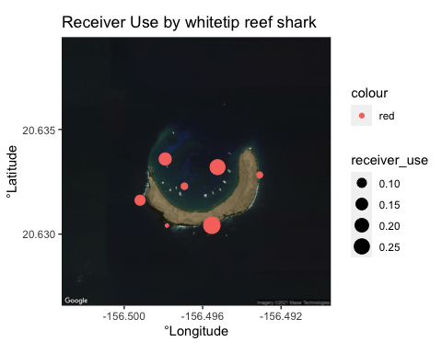

### Day Night Plots

### Day Night Plots  
## For all fish  
pdf(file = file.path(figure_directory, 'Day Night Plot - All Fish.pdf'))  
plot_day_night(molo_df, plot_title = 'All Fish')  
dev.off()

## quartz_off_screen   
## 2

## By Species  
for (spp in unique(molo_df$species)){  
 pdf(file = file.path(figure_directory, paste('Day Night Plot - Species ', spp, '.pdf', sep = '')))  
 plot_day_night(molo_df[molo_df$tag_id == molo_df$tag_id[molo_df$species == spp], ], plot_title = spp)  
 dev.off()  
}

## Warning in molo_df$tag_id == molo_df$tag_id[molo_df$species == spp]: longer  
## object length is not a multiple of shorter object length  
  
## Warning in molo_df$tag_id == molo_df$tag_id[molo_df$species == spp]: longer  
## object length is not a multiple of shorter object length  
  
## Warning in molo_df$tag_id == molo_df$tag_id[molo_df$species == spp]: longer  
## object length is not a multiple of shorter object length  
  
## Warning in molo_df$tag_id == molo_df$tag_id[molo_df$species == spp]: longer  
## object length is not a multiple of shorter object length  
  
## Warning in molo_df$tag_id == molo_df$tag_id[molo_df$species == spp]: longer  
## object length is not a multiple of shorter object length

## By Individual  
for (tag_id in unique(molo_df$tag_id)){  
 pdf(file = file.path(figure_directory, paste('Day Night Plot - Tag ID ', tag_id, '.pdf', sep = '')))  
 plot_day_night(molo_df[molo_df$tag_id == tag_id, ], plot_title = paste(tagging_df$species[tagging_df$tag_id == tag_id], '- Tag', as.character(tag_id), sep = ' '))  
 dev.off()  
}

### Barplot of detections by date

### Bar plot of detections in crater by date   
detections_per_day_df = count_detections_per_date(molo_df)  
  
## Barplot of detections by individual  
for(i in 1:nrow(detections_per_day_df)){  
 ## Convert from wide to long format  
 indv_data = melt(detections_per_day_df[i, ])  
 colnames(indv_data) = c('date', 'detections')  
   
 ## Make and save plot  
 ggplot(data = indv_data, mapping = aes(x = date, y = detections)) +  
 geom_bar(stat = "identity") +   
 labs(title = paste('Tag ', rownames(detections_per_day_df)[i], sep = ' '), x = 'Date', y = 'Detections') +   
 ggsave(filename = paste('Daily Detection Barplot -', rownames(detections_per_day_df)[i], '.pdf'), path = figure_directory)  
}

## No id variables; using all as measure variables

## Saving 5 x 4 in image

## No id variables; using all as measure variables

## Saving 5 x 4 in image

## No id variables; using all as measure variables

## Saving 5 x 4 in image

## No id variables; using all as measure variables

## Saving 5 x 4 in image

## No id variables; using all as measure variables

## Saving 5 x 4 in image

## No id variables; using all as measure variables

## Saving 5 x 4 in image

## No id variables; using all as measure variables

## Saving 5 x 4 in image

## No id variables; using all as measure variables

## Saving 5 x 4 in image

## No id variables; using all as measure variables

## Saving 5 x 4 in image

## Detections by species  
detections_per_day_spp_stg = detections_per_day_df  
detections_per_day_spp_stg$tag_id = rownames(detections_per_day_spp_stg)  
detections_per_day_spp_stg = left_join(x = detections_per_day_spp_stg, tagging_df[ ,c('tag_id', 'species')], by = 'tag_id')  
  
## Loop through species  
for (spp in unique(detections_per_day_spp_stg$species)){  
   
 ## Subset individual df by species  
 spp_subset_df = detections_per_day_spp_stg[detections_per_day_spp_stg$species == spp, -which(colnames(detections_per_day_spp_stg) %in% c('tag_id', 'species'))]  
   
 ## Convert to long format  
 detections_per_spp = melt(colSums(spp_subset_df), value.name = 'detections')  
 detections_per_spp$date = rownames(detections_per_spp)  
   
 ## Make and save plot  
 ggplot(data = detections_per_spp, mapping = aes(x = date, y = detections)) +  
 geom_bar(stat = "identity") +   
 labs(title = spp, x = 'Date', y = 'Detections') +   
 ggsave(filename = paste('Daily Detection Barplot -', spp, '.pdf'), path = figure_directory)  
}

## Saving 5 x 4 in image  
## Saving 5 x 4 in image  
## Saving 5 x 4 in image  
## Saving 5 x 4 in image  
## Saving 5 x 4 in image

## Barplot of all detections  
all_detections = colSums(detections_per_day_df)  
## Convert to long format  
all_detections_long = melt(all_detections, value.name = 'detections')  
all_detections_long$date = rownames(all_detections_long)  
   
## Make and save plot  
ggplot(data = all_detections_long, mapping = aes(x = date, y = detections)) +  
geom_bar(stat = "identity") +   
labs(title = 'All Tagged Individuals', x = 'Date', y = 'Detections') +   
ggsave(filename = paste('Daily Detection Barplot - all tags.pdf'), path = figure_directory)

## Saving 5 x 4 in image

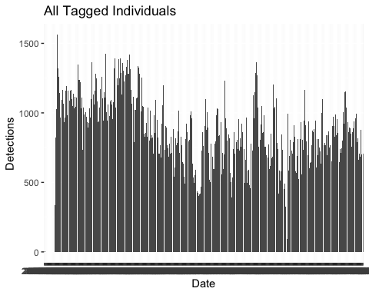

### Bar plot # of Fish (standardized percent of fish tagged to date) by date and Spp

THIS NEEDS WORK!!!

### Bar plot vessel traffic by date

In the future, might also consider max vessels present at a given time

## Calculate Daily Vessel Stats  
vessels_per_day = aggregate(vessel_name ~ date, data = vessel_df, FUN = uniqueN)  
colnames(vessels_per_day) = c('date', 'daily_vessels')  
  
# Make plot for total   
total_vessels_plot = ggplot(data = vessels_per_day, mapping = aes(x = date, y = daily_vessels)) +   
 geom_bar(stat = 'identity') +   
 labs(title = 'Maximum Number of Co-occuring Vessels Daily', x = 'Date', y = '# of Vessels') +  
 ggsave(filename = paste('Total Vessels Daily.pdf ', species, '.pdf', sep = ''), path = figure_directory)

## Saving 5 x 4 in image

print(total_vessels_plot)

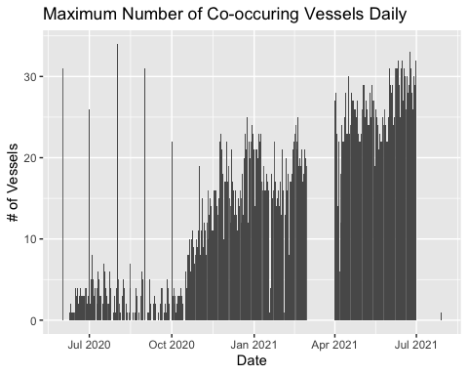

### Scatter plot x axis boat traffic, y axis detections per individual color by spp add error bars for daily detections

## combine vessel and detections per individual  
detections_per_day_per_tag = aggregate(datetime ~ date + tag_id + species, data = molo_df, FUN = uniqueN)  
colnames(detections_per_day_per_tag) = c('date', 'tag_id', 'species', 'daily_detections')  
detection_vessel_counts = left_join(detections_per_day_per_tag, vessels_per_day, by = 'date')  
  
ggplot(data = detection_vessel_counts, mapping = aes(x = daily_vessels, y = daily_detections, color = species)) + geom_point() + ggsave(filename = file.path(figure_directory, 'detections vs vessels.pdf'))

## Saving 5 x 4 in image

## Warning: Removed 475 rows containing missing values (geom_point).  
  
## Warning: Removed 475 rows containing missing values (geom_point).

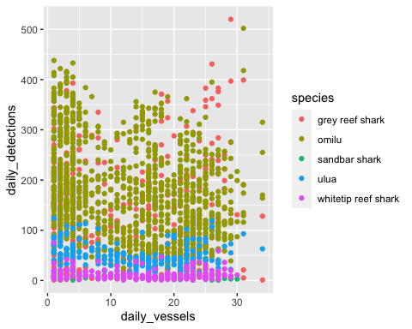 # Model the relationship between detections and vessels (this is ts data so this is just quick and dirty)

vessel_detection_glm = glm(daily_detections ~ daily_vessels, data = detection_vessel_counts, family = poisson)  
print(summary(vessel_detection_glm))

##   
## Call:  
## glm(formula = daily_detections ~ daily_vessels, family = poisson,   
## data = detection_vessel_counts)  
##   
## Deviance Residuals:   
## Min 1Q Median 3Q Max   
## -17.166 -8.347 -1.554 5.236 28.679   
##   
## Coefficients:  
## Estimate Std. Error z value Pr(>|z|)   
## (Intercept) 5.0458586 0.0033706 1497.03 <2e-16 ***  
## daily_vessels -0.0130406 0.0002241 -58.18 <2e-16 ***  
## ---  
## Signif. codes: 0 '***' 0.001 '**' 0.01 '*' 0.05 '.' 0.1 ' ' 1  
##   
## (Dispersion parameter for poisson family taken to be 1)  
##   
## Null deviance: 158720 on 1939 degrees of freedom  
## Residual deviance: 155305 on 1938 degrees of freedom  
## (475 observations deleted due to missingness)  
## AIC: 167410  
##   
## Number of Fisher Scoring iterations: 5

plot(vessel_detection_glm)

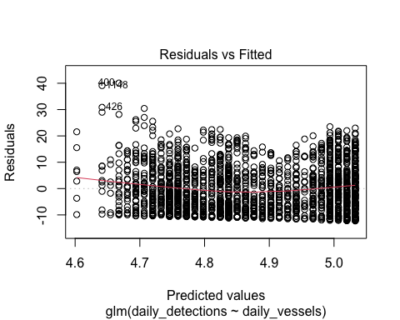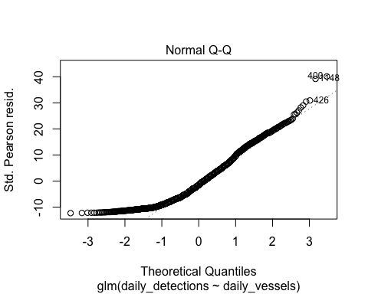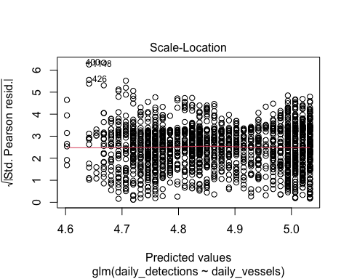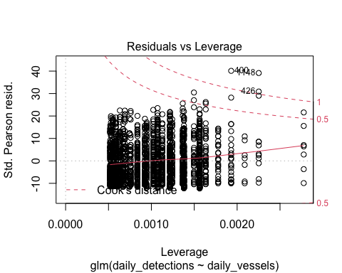 Conclusion: There does appear to be a negative trend where increased vessel traffic results in fewer fish. See coefficients. Need to dig deeper if trying to publish these results though, model should be better

# Residency and dispersal

## Calculate residency  
detection_stats$residence_metric = detection_stats$unique_days / detection_stats$days_at_liberty  
  
## Assign residence category: low = < 33%, medium = 33 - 66, high = >= 66 (Tinhan et al. 2014) -  
detection_stats$residence_category = 'Low'  
for (i in 1:nrow(detection_stats)){  
 if (detection_stats$residence_metric[i] >= (1/3)) {  
 detection_stats$residence_category[i] = 'Medium'  
 }  
 if (detection_stats$residence_metric[i] >= (2/3)) {  
 detection_stats$residence_category[i] = 'High'  
 }  
}  
  
## Create grouped barplot of residency by species  
residence_counts_by_species = aggregate(tag_id ~ species + residence_category, data = detection_stats, FUN = length)  
  
ggplot(data = residence_counts_by_species, mapping = aes(x=species, y=tag_id, fill=residence_category)) +  
 geom_bar(stat="identity", position = "dodge")

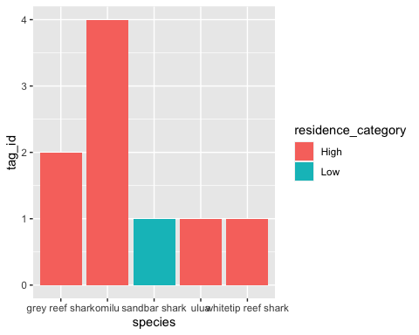

Takeaways - All 4 omilus were highly resident as were grey reef sharks. No other species have replicates so…?

## Calculate 30 day moving average of residency, then plot against days since tagging

## Get total days in the study  
total_days_in_study = as.numeric(diff.Date(c(min(molo_df$date), max(molo_df$date))))  
  
## Create a dataframe where rows are tag id and columns are study date  
present_after_n_days_df = data.frame()  
  
## Determine if a tag was detected on a receiver n days after tagging  
for (i in 1:uniqueN(molo_df$tag_id)){  
 ## Subset data for individual tags  
 indv_data = molo_df[molo_df$tag_id == unique(molo_df$tag_id)[i], ]  
 ## Determine if a fish was present n days after tagging  
 difftimes = rep(0, len = total_days_in_study)  
 # determine difference in days between each unique day a tag was detected and the tag's earliest detection, flip the corresponding value in difftimes array to 1  
 detected_dates = unique(indv_data$date)  
 for (j in 1:length(detected_dates)){  
 difftimes[as.numeric(diff.Date(c(min(indv_data$date), detected_dates[j]))) + 1] = 1  
 }  
 df_row = c(unique(molo_df$tag_id)[i], difftimes)  
 present_after_n_days_df = rbind(present_after_n_days_df, df_row)  
}  
colnames(present_after_n_days_df) = c('tag_id', as.character(1:total_days_in_study))  
  
## Convert from wide format to long format  
present_after_n_days_df_long_df = melt(present_after_n_days_df, id.vars = 'tag_id', measure.vars = colnames(present_after_n_days_df)[2:ncol(present_after_n_days_df)], variable.name = 'day', value.name = 'detected')  
  
## Merge with species data  
present_after_n_days_df_long_df = left_join(x = present_after_n_days_df_long_df, y = tagging_df[ ,c('tag_id', 'species')], by = 'tag_id')  
# Recast to numeric because of the join function  
present_after_n_days_df_long_df$detected = as.numeric(present_after_n_days_df_long_df$detected)  
  
## Calculate number of each species present n days after tagging  
species_presence_after_tagging = aggregate(detected ~ species + day, data = present_after_n_days_df_long_df, FUN = sum)  
 colnames(species_presence_after_tagging) = c('species', 'day', 'n_detected')  
  
## Count unique tags by species  
individuals_per_species = aggregate(tag_id ~ species, data = present_after_n_days_df_long_df, FUN = uniqueN)  
colnames(individuals_per_species) = c('species', 'n_tagged')  
  
## Standardize species level daily counts by number of tags belonging to that species  
species_presence_after_tagging = left_join(x = species_presence_after_tagging, y = individuals_per_species, by = 'species')  
species_presence_after_tagging$percent_individuals_detected = species_presence_after_tagging$n_detected / species_presence_after_tagging$n_tagged  
  
## Convert day from factor to numeric  
species_presence_after_tagging$day = as.numeric(levels(species_presence_after_tagging$day)[species_presence_after_tagging$day])  
  
## remove any NA days  
species_presence_after_tagging = species_presence_after_tagging[!is.na(species_presence_after_tagging$day), ]  
  
## Calculate 30 day moving average  
spp_presence_30_day_avg = data.frame()  
for (species in unique(species_presence_after_tagging$species)){  
 spp_presence_after_tagging = species_presence_after_tagging[species_presence_after_tagging$species == species, ]  
 moving_average_30 = c()  
 for (i in 30:max(spp_presence_after_tagging$day)){  
 moving_average_30 = c(moving_average_30, mean(spp_presence_after_tagging$percent_individuals_detected[spp_presence_after_tagging$day >= i-30 & spp_presence_after_tagging$day <= i]))  
 }  
 df_row = c(species, moving_average_30)  
 spp_presence_30_day_avg = rbind(spp_presence_30_day_avg, df_row)  
}  
colnames(spp_presence_30_day_avg) = c('species', as.character(1:(ncol(spp_presence_30_day_avg)-1)))  
  
## Convert from wide format to long format  
spp_presence_30_day_avg_long_df = melt(spp_presence_30_day_avg, id.vars = 'species', measure.vars = colnames(spp_presence_30_day_avg)[2:ncol(spp_presence_30_day_avg)], variable.name = 'day', value.name = 'percent_individuals_detected')  
  
# Convert percent_individuals_detected and date  
spp_presence_30_day_avg_long_df$percent_individuals_detected = as.numeric(spp_presence_30_day_avg_long_df$percent_individuals_detected)  
  
spp_presence_30_day_avg_long_df$day = as.numeric(levels(spp_presence_30_day_avg_long_df$day)[spp_presence_30_day_avg_long_df$day])  
  
  
## Generate line plot  
present_after_tagging_plot = ggplot(spp_presence_30_day_avg_long_df, mapping = aes(x = day, y = percent_individuals_detected, color = species)) +   
 geom_line() +   
 labs(x = 'Number of days', y = 'Proportion present') +  
 ggsave(filename = 'Proportion of tags present after tagging.pdf', path = figure_directory)

## Saving 5 x 4 in image

print(present_after_tagging_plot)

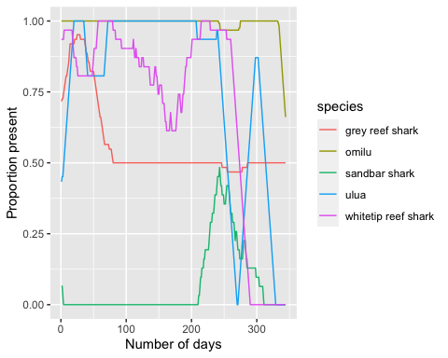

# Statistical analysis

Calculate mean residency by spp (irregardless of time), then ANOVA by spp Use Tukey’s HSD to determine significance

## ANOVA model for residency metric by species  
residence_by_species_anova = aov(residence_metric ~ species, data=detection_stats)  
summary(residence_by_species_anova)

## Df Sum Sq Mean Sq F value Pr(>F)   
## species 4 0.6781 0.16954 36.28 0.00212 **  
## Residuals 4 0.0187 0.00467   
## ---  
## Signif. codes: 0 '***' 0.001 '**' 0.01 '*' 0.05 '.' 0.1 ' ' 1

## Tukey's Honestly Significant Differences between species  
TukeyHSD(residence_by_species_anova)

## Tukey multiple comparisons of means  
## 95% family-wise confidence level  
##   
## Fit: aov(formula = residence_metric ~ species, data = detection_stats)  
##   
## $species  
## diff lwr upr p adj  
## omilu-grey reef shark 0.13134256 -0.1318229 0.3945080 0.3282773  
## sandbar shark-grey reef shark -0.78499266 -1.1571648 -0.4128205 0.0034142  
## ulua-grey reef shark -0.04021073 -0.4123829 0.3319614 0.9852738  
## whitetip reef shark-grey reef shark 0.01604564 -0.3561265 0.3882178 0.9995567  
## sandbar shark-omilu -0.91633521 -1.2560803 -0.5765901 0.0013197  
## ulua-omilu -0.17155329 -0.5112984 0.1681918 0.3205721  
## whitetip reef shark-omilu -0.11529692 -0.4550421 0.2244482 0.6064486  
## ulua-sandbar shark 0.74478192 0.3150345 1.1745293 0.0071653  
## whitetip reef shark-sandbar shark 0.80103830 0.3712909 1.2307857 0.0054544  
## whitetip reef shark-ulua 0.05625637 -0.3734910 0.4860037 0.9710009

GLM comparing residency time by spp independent var (time at liberty) dependent (residency index)

## Fit binomial GLM to average residency metric data (proportional between 0-1)  
species_glm = glm(residence_metric ~ species * days_at_liberty, data = detection_stats, family = binomial(logit))

## Warning in eval(family$initialize): non-integer #successes in a binomial glm!

summary(species_glm)

##   
## Call:  
## glm(formula = residence_metric ~ species * days_at_liberty, family = binomial(logit),   
## data = detection_stats)  
##   
## Deviance Residuals:   
## 1 2 3 4 5 6   
## 9.551e-09 9.551e-09 0.000e+00 -5.845e-09 0.000e+00 0.000e+00   
## 7 8 9   
## 9.551e-09 0.000e+00 0.000e+00   
##   
## Coefficients: (3 not defined because of singularities)  
## Estimate Std. Error z value  
## (Intercept) 6.656e-01 3.305e+00 0.201  
## speciesomilu 4.221e+00 3.984e+03 0.001  
## speciessandbar shark -5.228e+00 5.534e+00 -0.945  
## speciesulua -1.367e+00 5.170e+00 -0.264  
## specieswhitetip reef shark -6.425e-01 4.904e+00 -0.131  
## days_at_liberty 6.902e-03 1.952e-02 0.354  
## speciesomilu:days_at_liberty -4.132e-03 1.099e+01 0.000  
## speciessandbar shark:days_at_liberty NA NA NA  
## speciesulua:days_at_liberty NA NA NA  
## specieswhitetip reef shark:days_at_liberty NA NA NA  
## Pr(>|z|)  
## (Intercept) 0.840  
## speciesomilu 0.999  
## speciessandbar shark 0.345  
## speciesulua 0.791  
## specieswhitetip reef shark 0.896  
## days_at_liberty 0.724  
## speciesomilu:days_at_liberty 1.000  
## speciessandbar shark:days_at_liberty NA  
## speciesulua:days_at_liberty NA  
## specieswhitetip reef shark:days_at_liberty NA  
##   
## (Dispersion parameter for binomial family taken to be 1)  
##   
## Null deviance: 4.3149e+00 on 8 degrees of freedom  
## Residual deviance: 1.5038e-16 on 2 degrees of freedom  
## AIC: 15.426  
##   
## Number of Fisher Scoring iterations: 8

No Significant differences found

## GLM comparing time in crater to vessel traffic - Still to come